Valuing a Defined Benefit Pension Scheme: Funding Position and Risk

Summary
A defined benefit pension scheme promises its members a pension for life, so the sponsoring employer must hold enough assets today to pay these pensions in the future. This report values a small illustrative scheme of 100 members using R, Python and Excel to establish whether the scheme has enough assets to meet its promises and how risky that position is. On the base assumptions, the scheme has liabilities of £9.27m against assets of £9.5m, which gives a funding level of 102.5%.
However, the scheme is only just fully funded and the position is fragile. A 1% fall in the discount rate increases the liability by 21.2% and moves the scheme into a deficit with a funding level of 84.6%. In addition, when random deaths are simulated 1,000 times, liabilities exceed assets in 26.7% of cases. Therefore, the trustees should consider building a larger buffer or reducing the scheme’s exposure to changes in the discount rate.

The scheme and the data
The scheme consists of 100 members: 60 active members who are still working and building up benefits, 20 deferred members who have left the employer but have not yet retired, and 20 pensioners who are already receiving a pension. Each member has an age, sex, salary and years of service. Members receive a pension of 1/60 of their final salary for each year of service, which is payable from the normal retirement age of 65.
It is important to note that the member data is entirely illustrative. It was generated randomly in Excel to resemble a realistic scheme and is not based on a real employer. Consequently, the results should be viewed as a demonstration of the valuation method as opposed to the true position of an actual pension scheme.

Assumptions
A pension valuation depends on assumptions about the future, so these are set out below together with the reason for each choice.
Assumption | Value | Reason for choice
Discount rate | 4.0% | Represents the expected long-term return on assets, and is used to convert future payments into today’s money.
Salary growth | 2.5% | Reflects long-term wage growth slightly above inflation, which affects the final salary of active members.
Withdrawal rate | 5.0% | A typical annual rate at which active members leave the scheme before retirement.
Pension increases | 2.0% | Pensions in payment increase each year to protect their buying power against inflation.
Retirement age | 65 | A standard normal retirement age for the scheme.

Mortality model
Mortality is crucial to a pension valuation because a pension is only paid while the member is alive. To model this, a Gompertz law was fitted to national life table death rates (mx) published by the Office for National Statistics for ages 30 to 95. The Gompertz law states that the force of mortality increases by a fixed percentage with each year of age, written as mx = a × exp(b × age). Taking logarithms turns this into a straight line, so the parameters a and b were estimated in R using linear regression of log(mx) on age, separately for males and females. The fitted parameters were then used to calculate the probability of each member surviving to each future age.
Figure 1: Males, real vs Gompertz fit
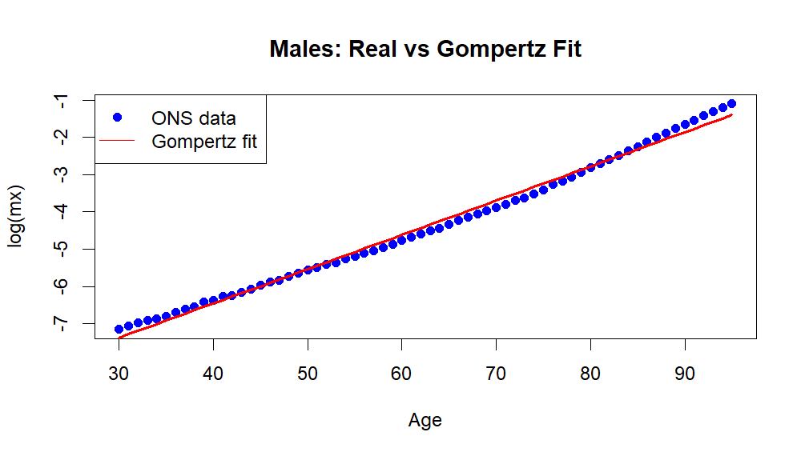
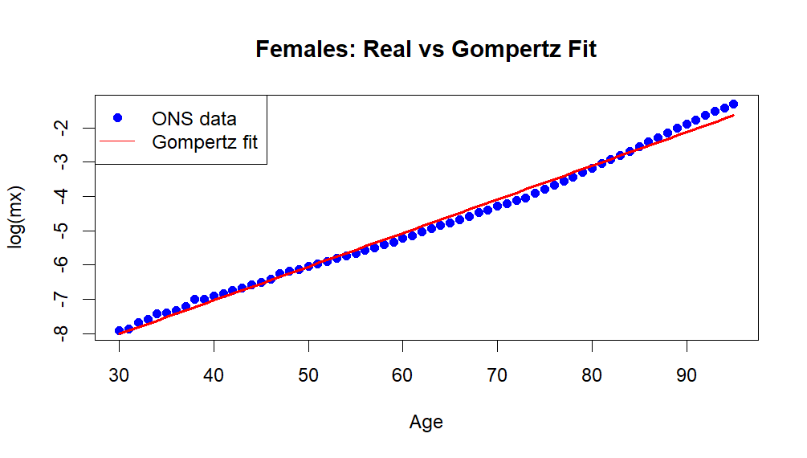
Figure 2: Females, real vs Gompertz fit

The fitted line follows the real data closely in middle and older ages, which is where almost all of the pension payments occur. This makes the model suitable for this valuation. On the contrary, it is important to consider that the Gompertz law fits less well at young ages, where death rates are affected by factors such as accidents that do not follow a steady exponential pattern. However, this has a limited impact on the results because few members are young and no pensions are paid until age 65.

Method
The liability was calculated by projecting each member’s pension year by year until the maximum age of 100. For active members, salary was grown to retirement at 2.5% a year and the pension was reduced each year by the 5% withdrawal rate to allow for members who leave before retirement. Each projected payment was then multiplied by the probability that the member is alive to receive it, and discounted back to today at 4%. The present values were added across all members to give the total liability.
To check that the model works, one pensioner was rebuilt by hand in Excel using separate formulas for survival, discounting and payment. The Excel result matched the Python code to the nearest pound, which provides confidence that the projection has been implemented correctly.

Results
The table below shows the liability for each group of members. Pensioners and deferred members make up the largest share because their pensions are closer to being paid, so they are discounted for less time than those of active members.
Group | Liability | Share of total
Active members | £2.73m | 29%
Deferred members | £3.12m | 34%
Pensioners | £3.42m | 37%
Total liability | £9.27m | 100%
Assets | £9.50m
Funding level | 102.5%

With assets of £9.5m, the scheme is in a small surplus of around £0.2m. This is a funding level of 102.5%, which means the scheme can meet its promises on the base assumptions but with very little margin for error.

Sensitivities
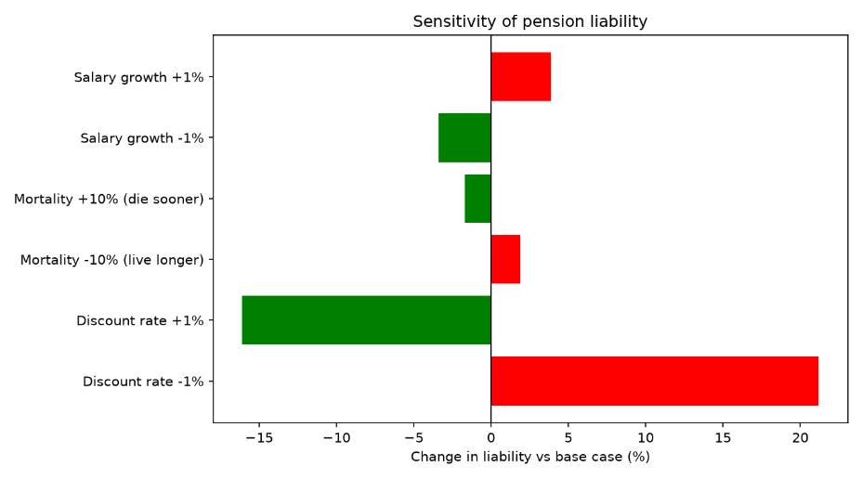
To understand how risky this position is, each assumption was changed one at a time while the others were held constant. The results are shown in the chart below.
Figure 3: Sensitivity of pension liability
Scenario | Liability | Change | Funding level
Base case | £9.27m | 0.0% | 102.5%
Discount rate -1% | £11.23m | +21.2% | 84.6%
Discount rate +1% | £7.77m | -16.1% | 122.2%
Mortality -10% (live longer) | £9.44m | +1.9% | 100.6%
Mortality +10% (die sooner) | £9.11m | -1.7% | 104.3%
Salary growth -1% | £8.95m | -3.4% | 106.1%
Salary growth +1% | £9.63m | +3.9% | 98.7%

The discount rate has by far the greatest impact on the liability. This is because a lower discount rate means future pensions are worth more in today’s money, and pensions are paid over many decades, so the effect builds up over a long period. A 1% fall in the discount rate increases the liability by 21.2% and pushes the scheme into a deficit. Salary growth is the second most important assumption at around 4%, although its effect is limited because it only affects the 60 active members. Mortality has the smallest effect at around 2%. Nevertheless, if members live 10% longer than expected, the funding level falls to 100.6%, which shows how little margin the scheme has.

Monte Carlo simulation
The valuation above treats every member as an average person, but in reality each member either dies in a given year or does not. To capture this randomness, the death of each member was simulated year by year using the fitted Gompertz death rates, and the total liability was recalculated for each of 1,000 simulations.
Figure 4: Monte Carlo distribution of pension liability
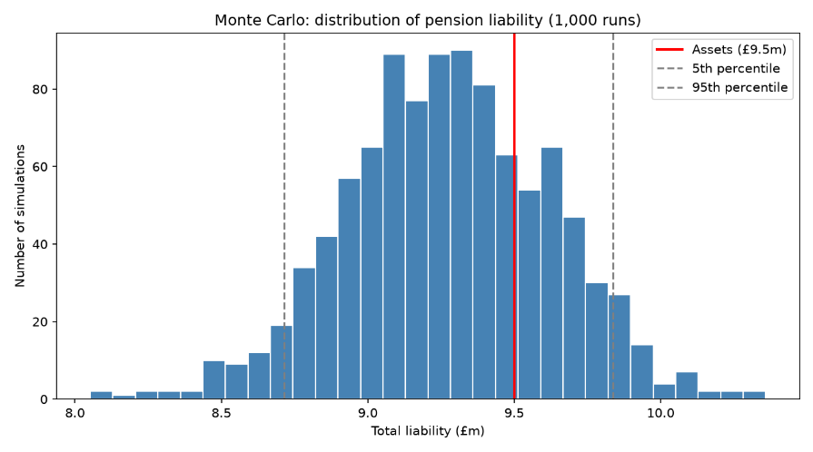
The mean simulated liability was £9.27m, which is within 0.1% of the base case and shows that the simulation agrees with the main valuation. The standard deviation was £0.35m, and 90% of the simulations produced a liability between £8.71m (5th percentile) and £9.84m (95th percentile). Since the assets of £9.5m are only about 2.5% above the average liability, a significant number of simulations fall to the right of the asset line. As a result, the liability exceeds the assets in 26.7% of simulations, which means there is roughly a 1 in 4 chance of a deficit from longevity risk alone.

Limitations
There are several limitations that should be considered when interpreting these results. Firstly, the member data is made up and the scheme is small, so the results are illustrative and cannot be applied to a real scheme. Secondly, active members who withdraw are removed from the calculation rather than becoming deferred members. This slightly understates the liability because those members would still be entitled to a deferred pension.
Thirdly, the Monte Carlo simulation only models the deaths and does not model investment returns, salary changes or inflation. Therefore, it captures longevity risk but underestimates the total risk the scheme faces, particularly as investment risk is likely to be significant. Finally, the mortality sensitivity is a simple 10% multiplier on the death rates and does not include future improvements in life expectancy. It could be argued that longer life expectancy in the future would increase the liability further, so the true longevity risk may be higher than shown.

Recommendation
The scheme is fully funded on the base assumptions, but at 102.5% it has very little buffer against adverse changes. The sensitivity and simulation results show that the position could easily move into a deficit. Therefore, it is recommended that the trustees build a larger funding buffer, for example through additional contributions from the employer, so that the scheme can withstand a moderate fall in the discount rate or an increase in life expectancy.
In addition, since the discount rate is the largest risk, the trustees should consider hedging against changes in it, for example by holding assets whose value moves in line with the liabilities. This would reduce the chance that a fall in the discount rate, which increases liabilities, pushes the scheme into a deficit. Finally, the trustees should monitor longevity experience regularly, because the results show that even small changes in mortality reduce the funding level when the scheme has so little margin.

